Test Case: tc001_SPX_Dev5_Crear_Requisicion_Spot_Tipo_Cobro_CC
Step 1 - Enter username and password and click to button Enter : Credentials Entered
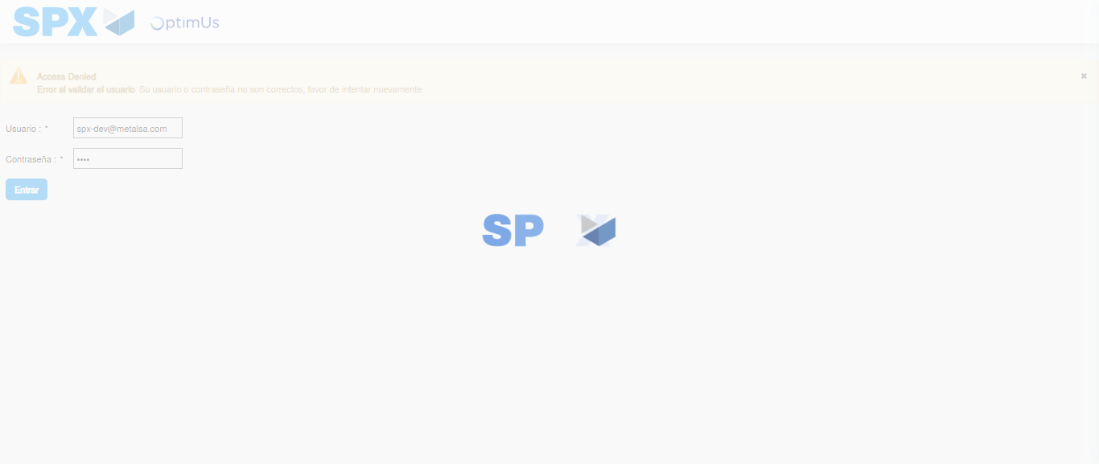Image file-name: QC_Testing-tc001_SPX_Dev5_Crear_Requisicion_Spot_Tipo_Cobro_CC-1783980831167

Step 2 - Select to UEN and Access to Spot Buy Requisitions : UEN Correctly selected and Correct access
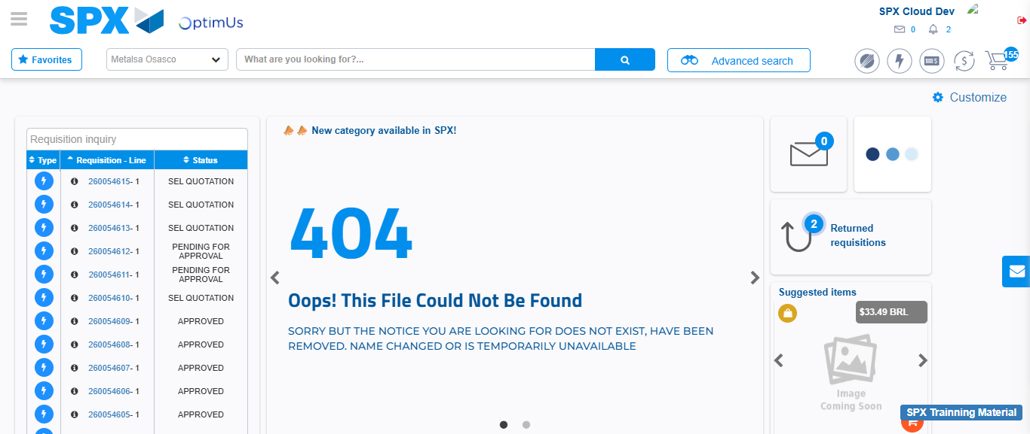Image file-name: QC_Testing-tc001_SPX_Dev5_Crear_Requisicion_Spot_Tipo_Cobro_CC-1783980857945

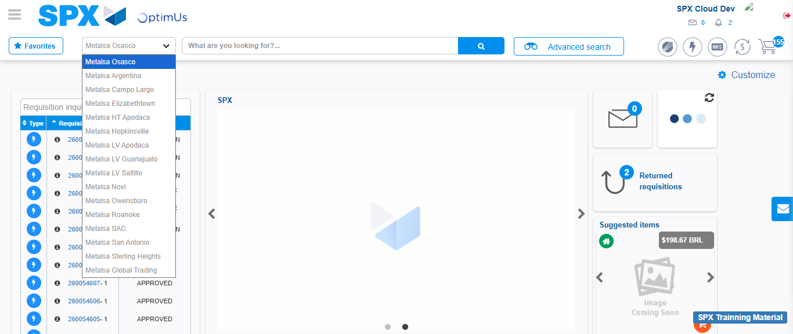Image file-name: QC_Testing-tc001_SPX_Dev5_Crear_Requisicion_Spot_Tipo_Cobro_CC-1783980860455

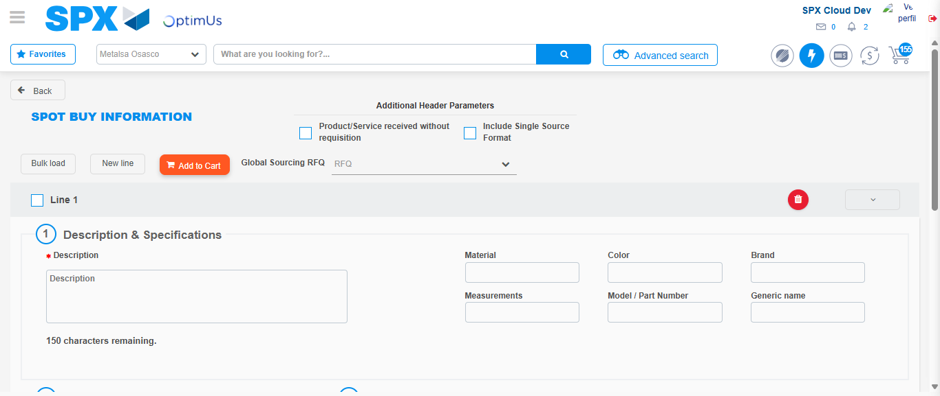Image file-name: QC_Testing-tc001_SPX_Dev5_Crear_Requisicion_Spot_Tipo_Cobro_CC-1783980879593

Step 3 - Data Capture Spot Buy Requisition : Data captured correctly
Image file-name: QC_Testing-tc001_SPX_Dev5_Crear_Requisicion_Spot_Tipo_Cobro_CC-1783980879873

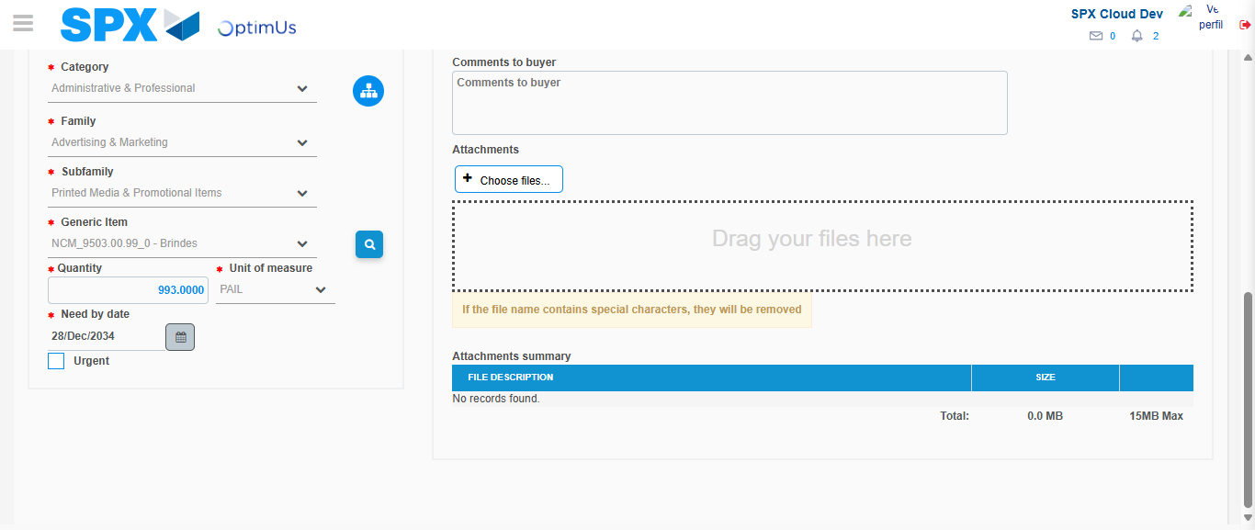Image file-name: QC_Testing-tc001_SPX_Dev5_Crear_Requisicion_Spot_Tipo_Cobro_CC-1783980891673

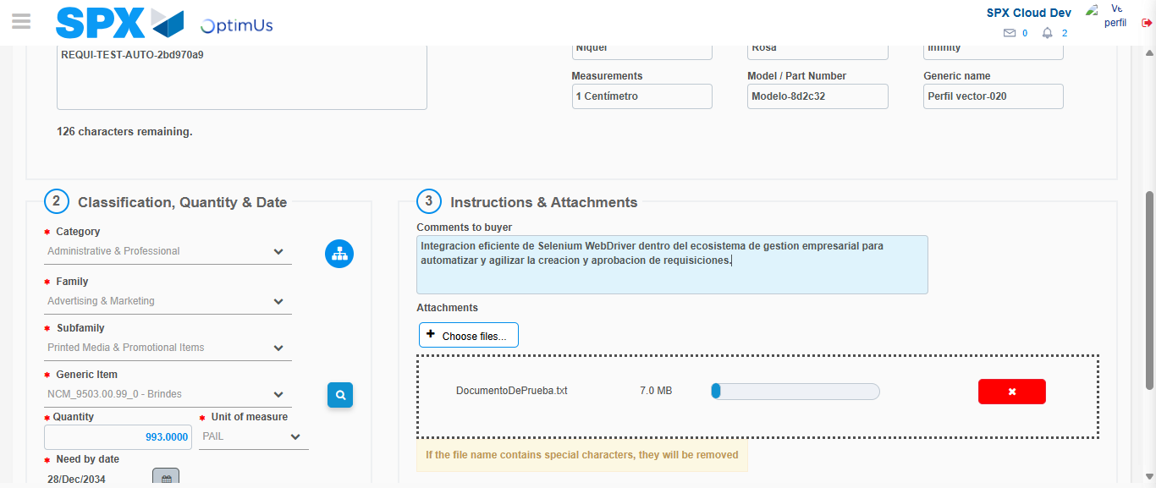Image file-name: QC_Testing-tc001_SPX_Dev5_Crear_Requisicion_Spot_Tipo_Cobro_CC-1783980892379

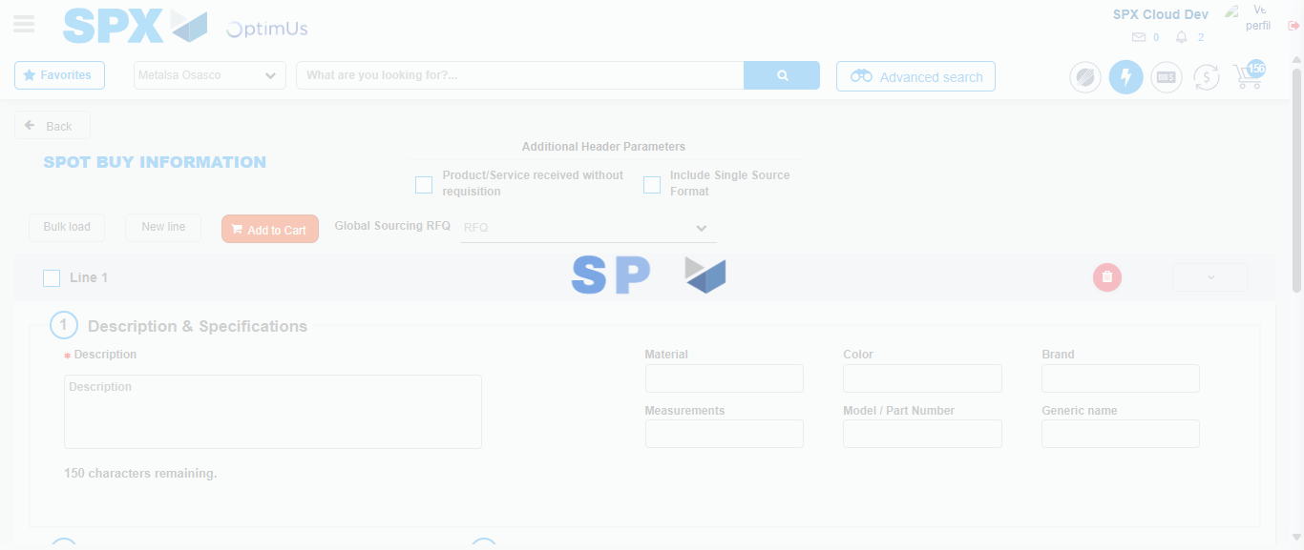Image file-name: QC_Testing-tc001_SPX_Dev5_Crear_Requisicion_Spot_Tipo_Cobro_CC-1783980906421

Step 7 - Return to Main Page SPX : Return to Main Page SPX
Image file-name: QC_Testing-tc001_SPX_Dev5_Crear_Requisicion_Spot_Tipo_Cobro_CC-1783980857945

Image file-name: QC_Testing-tc001_SPX_Dev5_Crear_Requisicion_Spot_Tipo_Cobro_CC-1783980860455

Image file-name: QC_Testing-tc001_SPX_Dev5_Crear_Requisicion_Spot_Tipo_Cobro_CC-1783980879593

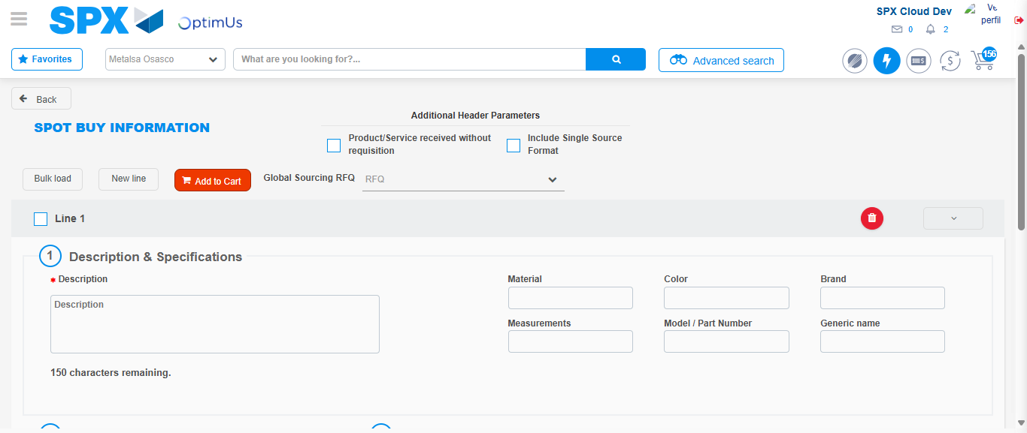Image file-name: QC_Testing-tc001_SPX_Dev5_Crear_Requisicion_Spot_Tipo_Cobro_CC-1783980908635

Image file-name: QC_Testing-tc001_SPX_Dev5_Crear_Requisicion_Spot_Tipo_Cobro_CC-1783980908793

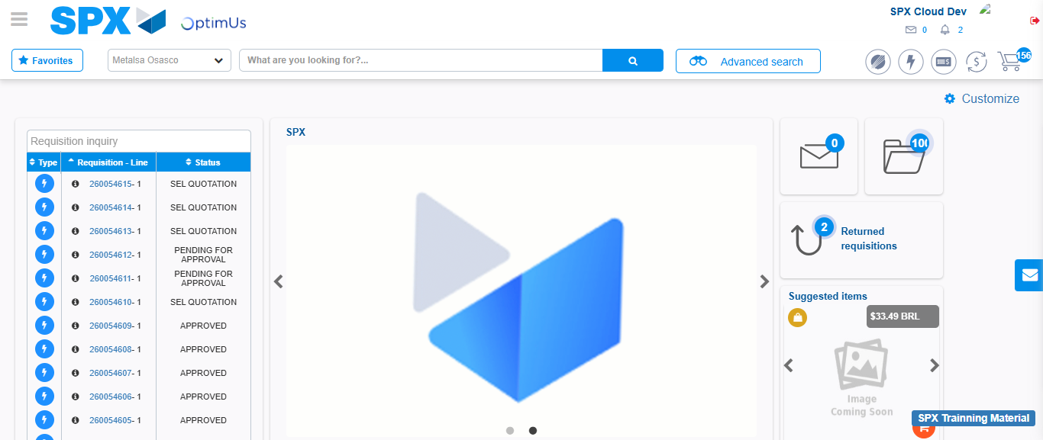Image file-name: QC_Testing-tc001_SPX_Dev5_Crear_Requisicion_Spot_Tipo_Cobro_CC-1783980929743

Step 8 - Log Out : Log Out SPX
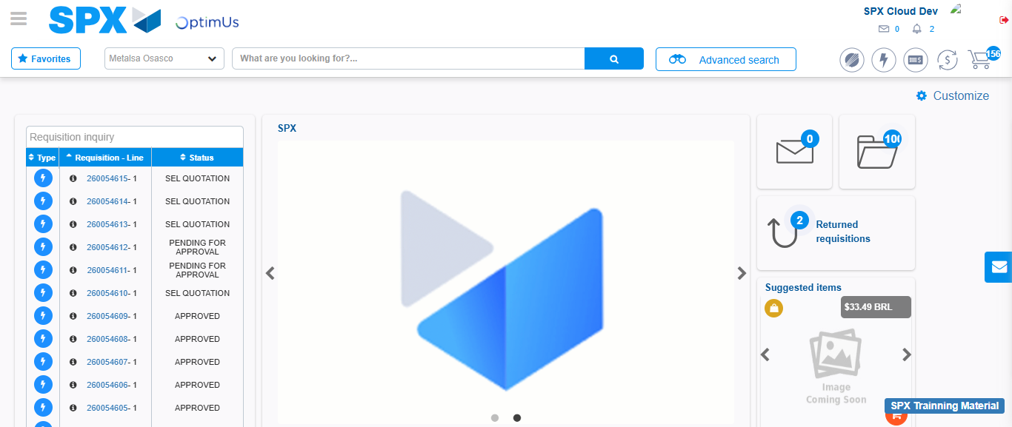Image file-name: QC_Testing-tc001_SPX_Dev5_Crear_Requisicion_Spot_Tipo_Cobro_CC-1783980929985

